Supplementary Information for:
THE DEVELOPING BIRD PELVIS PASSES THROUGH ANCESTRAL DINOSAURIAN CONDITIONS
Christopher T. Griffin, João F. Botelho, Michael Hanson, Matteo Fabbri, Ryan M. Carney, Mark A. Norell, Shiro Egawa, Stephen M. Gatesy, Timothy B. Rowe, Ruth M. Elsey, Sterling J. Nesbitt, Bhart-Anjan S. Bhullar

Contents
Supplementary Text S1. Historical Review

Supplementary Text S2. Supplementary Methods

Supplementary Text S3. Description of Alligator pelvic development
Supplementary Text S4. Pelvic covariances among the Ornithischia
Supplementary Text S5. Supplementary References

Supplementary Text S1. Historical Review
“...if the whole hind quarters...of a half-hatched chicken could be suddenly enlarged, ossified, and fossilized...there would be nothing in their characters to prevent us from referring them to the Dinosauria.”
—Thomas Huxley, 1870a
Our method of exploring embryonic avian tissues with a modified CLARITY protocol combined with confocal microscopy has led to the surprising observation that the early stages of avian pelvic development possess morphologies that strongly resemble ancestral archosaurian, dinosaurian, and theropod character states. Although we arrived at this observation and subsequent interpretation independently, three obscure embryological studies from the 19th century also reported a relatively short ilium and anteriorly directed pubis in early avian development (Bunge 1880; Johnson 1883; Mehnert 1887). Surprisingly, given that this was the heyday of both Haeckel’s and his contemporaries’ recapitulationist ideas (e.g., Cope 1866; 1870b; 1896; Haeckel 1866; 1874; Hyatt 1866; Weismann 1875; 1881; 1904; Schmidt 1909; reviewed by Gould 1977) and Huxley’s hypothesis that birds had evolved from a dinosaur-like ancestor (1870a; 1870b; 1870c; reviewed by Switek 2010), these embryological descriptions were never placed into a broader comparative context except to comment on the general ‘reptilian’ conformation of the embryonic pelves, never compared with theropod dinosaurs, and never placed into a recapitulationist framework (Haeckelian or otherwise). We suspect that a focus on different questions (primarily the homology of the pubis, which was under debate) and a nearly nonexistent fossil record of non-avialan theropod pelves contributed to the absence of comparative statements regarding theropods. This, in concert with an incomplete and incipient state of phylogenetic thinking (Rieppel 2016), led to these initial observations never developing into more fruitful research programs at the time. After the turn of the 20th century the idea that birds are theropod dinosaurs, or at least that they both evolved from a similar common ancestor, had fallen out of favor and subsequent workers had little context with which to interpret these embryological data, even as the dinosaurian fossil record grew to be much better sampled. By the time that fossil sampling and new phylogenetic methods began to strongly suggest that birds are dinosaurs in the latter half of the 20th century, the early avian embryological descriptions had been largely forgotten, and were never used to support the now consensus view (e.g., Smith et al. 2015) that birds are theropod dinosaurs.
Descriptions of in ovo avian development have been published since at least Aristotle (History of Animals, Book VI), but to our knowledge the first description and illustration of the early development of the avian pelvis was in the doctoral dissertation of Alexander Bunge (1880) of the Kaiserlichen Universität, who cut sagittal sections of the pelvic area of bird embryos by hand and observed pre-cartilaginous condensations (Fig. S1A). Bunge (1880) noted both the forward-facing pubis and anteriorly shortened ilium of early-stage bird embryos, and he commented on its interest given Huxley’s (1870a; 1870b; 1870c) ideas about the relationship between dinosaurs and birds. He verbally compared the embryonic pelvis to that of the ornithischian dinosaur Hypsilophodon illustrated by Huxley (1870c) but concluded that the ornithischian pelvis is more similar to that of a mature bird, and that the embryonic bird pelvis is more similar to that of the lizard Lacerta vivipara. The main focus of the dissertation was on a general developmental description and the homologies of the crocodylian and avian pubis, the “prepubis”, the “postpubis”, and the avian “pectineal process”, which were heavily debated at the time (e.g., Hoffman 1876; Huxley 1879; Romer 1927a; Hutchinson 2001; Claessons and Vickaryous 2012). Bunge (1880) never compared the avian pelvis with theropod dinosaurs or discussed the evolutionary implications of that what he observed, although the fossil record of theropods was lacking for good comparative material at the time.
Alice Johnson (1883) was next to study the development of the avian pelvis, illustrating the forward-facing pubis found in early-stage bird embryos (Fig. S1B). Although she briefly compared the early embryonic pelvis to the pelves of dinosaurs, this was in a broader context in which the pelvis of the duck-billed platypus (Ornithorhynchus) was also compared, and like Bunge (1880) she was more interested in homology problems related to the pubis. Incidentally, this was Johnson’s first scientific publication, which she accomplished as a student at Cambridge University. She was one of the first women to take an active role in leading zoological research in England, and her second publication was the first by a woman to be published in the Proceedings of the Royal Society (Johnson 1884). Today, her biological research, including these early observations of avian development, has largely been forgotten (Creese 1998).
Ernst Mehnert (1887) was, to our knowledge, the last researcher to clearly show the developing avian pelvis with its forward-facing pubis and shortened ilium until our own work, also providing the clearest images of this embryonic morphology (Fig. S1C) besides our CLARITY images. Additionally, he directly and visually compared this morphology to that of a dinosaur (Fig. S1D), although it was a pelvis of a sauropod and not a theropod dinosaur. However, no statements of evolutionary relationship are made by this comparison—Mehnert actually concluded that “[t]he dinosaurs, especially the ornithopod dinosaurs, are not ancestors of the birds…” (pp. 76–77, translated from the original German)—and a main focus of the paper, like the previous studies, is whether the avian pubis is a “postpubis” or true pubis. This is especially surprising given that Mehnert was a strong supporter of a non-Haeckelian version of heterochronic, organ-independent recapitulationism (e.g., Mehnert 1891; 1895; 1897), although in Gould’s (1977) reading he was less interested in applying Haeckel’s so-called biogenetic law.
Other illustrations of avian pelvic development (Parker 1891; Broom 1905) generally focused on later developmental stages, and the ancestral character states noted in previous work (Bunge 1880; Johnson 1883; Mehnert 1887) were not as apparent. Before Bunge’s (1880) description, Richard Owen (1863a; 1863b) noted that the developing avian embryo has a short sacrum, similar to that of Archaeopteryx, but he did not describe development of the pelvis. Osborn (1900), citing a figure from Mehnert (1887), noted that the early-stage embryonic pelvis resembled “primitive carnivorous dinosaurs,” (p. 783), although this was only taken as evidence that birds and dinosaur arose from a common ancestor, and explicitly not that birds are the direct descendants of dinosaurs. Broom (1905) criticized interpretations of what he called “procartilage” in these studies, stating that it is “well-nigh impossible” (p. 360) to differentiate these condensations from other tissues in the embryonic bird, and concluding that birds are not the descendants of theropod dinosaurs, but that dinosaurs, pterosaurs, and birds all evolved from a single common form. This criticism was echoed by Lebedinsky (1913), who reviewed Bunge (1880), Johnson (1883), and Mehnert (1887) and surmised that the differences between their figures were largely because of differences in the cuts made, and that the ontogenetic stage was too early for true cartilage to form, only the more difficult-to-observe cartilage precursor, making the real morphology uncertain and difficult to properly interpret. D’Arcy Thompson’s influential 1917 work On Growth and Form (edited and abridged by Bonner in 1961) includes a discussion of the transition between the pelvic morphology of Archaeopteryx and a crown bird, illustrating a deformation mesh that is strikingly similar to those produced by our own geometric analyses (Fig. S2), but includes no mention of embryonic development. Largely, the consensus of other workers followed the original observations (Bunge 1880; Johnson 1883; Mehnert 1887) that the avian pelvis seemed broadly similar to a basic reptilian plan, but this was never used to support a dinosaurian ancestry of birds or placed into an evolutionary context, and the certainty of the morphology reported was frequently questioned.
With the publication of The Origin of Birds (Heilmann 1927), an extremely influential work that argued against a theropod and dinosaurian origin of birds, the ‘birds are dinosaurs’ hypothesis largely fell to the wayside for a generation. This book illustrates (Heilmann 1927: Fig. 73) the embryonic pelves from Bunge (1880), Johnson (1883), and Mehnert (1887), but they are only compared broadly to other reptiles and mammals. Following this, embryonic pelves were rarely described or figured in the literature, and almost never in relation to dinosaurian pelvic morphology. Romer’s (1927b) classic description of chick muscular development contains an illustration with an early-stage pubis that may be interpreted as forward-facing (Fig. 2a), although it is almost entirely obscured by the illustrated musculature. Three years later a review arguing that birds are more closely related to pterosaurs and ornithischians, to the exclusion of theropods, noted that the avian pubis retroverts during development (Goodrich 1930). Subsequently, the generally “reptilian” configuration of the early-stage avian pelvis first noted in the 19th century was referenced, although the uncertainty regarding the methods used lent these interpretations to criticism (Hamilton 1952; Romanoff 1960), and such early stages were often not described in detail because of methodological constraints (Starck 1993).
By the time the hypothesis that birds are living members of the Theropoda had again gained traction in the 1960s and 70s, this time supported by a much better-sampled fossil record and more repeatable phylogenetic methods (Ostrom 1969; 1973; 1975; 1976a; 1976b; Gauthier 1984; 1986; Smith et al. 2015), the early descriptions of avian embryonic pelves had been nearly forgotten, and the study of ontogeny in the context of evolution had fallen out of vogue (reviewed in Gould 1977). The observation that the avian pubis retroverts during development has been used to suggest that some developmental mechanism could be responsible for the convergence between ornithischian and avian pubes (Rasskin-Gutman and Buscalioni 2001). Other brief instances of a forward-facing avian pubis in the more recent literature include a study of the developmental regulation of the avian pelvic girdle that verbally described the developing pubis as facing cranioventrally (Malashichev et al. 2005), and a description of paleognath ossification sequences briefly mentioned that at early stages the pubis is ventrally directed and begins to rotate posteriorly, but this is not figured, highlighted, or discussed to any extent (Maxwell and Larsson 2009). A study of joint shape morphogenesis showed what may be interpreted as an anteriorly directed pubis in a few embryonic stages, but it is not figures clearly and is presented without comment or description (Nowlan and Sharpe 2014). Our study has therefore provided independent validation of those original, oft-criticized embryological descriptions (Bunge 1880; Johnson 1883; Mehnert 1887), visualizing a growth series of multiple tissues (cartilage, muscle, nerve) in three dimensions across growth series instead of two-dimensional slices of cartilage condensate illustrated by hand in a single individual. Because of an excellent fossil record, the morphological transition from theropod dinosaurs to birds is now well-constrained, allowing us to place these observations into a comparative evolutionary context that was not previously available. Although it has taken 140 years and required numerous conceptual and technological innovations in embryology, paleontology, phylogenetics, and statistics, the initial observations by Alexander Bunge, Alice Johnson, and Ernst Mehnert can finally be built upon and placed into a well-supported comparative evolutionary framework.
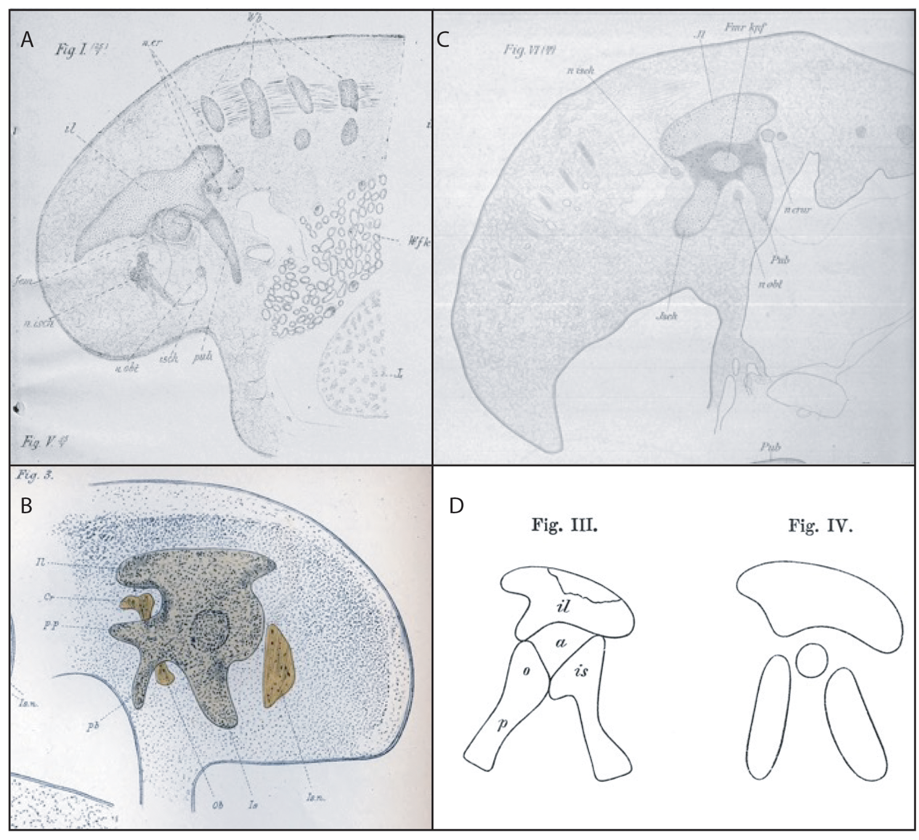
Figure S1. Nineteenth-century illustrations of sagitally cut, early stage embryonic avian pelves. A. Figure 1 from Bunge (1880), right lateral view. B. Figure 3 from Johnson (1883) in left lateral view. C. Figure 6 from Mehnert (1887), right lateral view. D. Figures 3 and 4 from Mehnert (1887) showing a depiction of a sauropod pelvis (left) and an embryonic avian pelvis (right) in left lateral view. All illustrations are in the public domain.

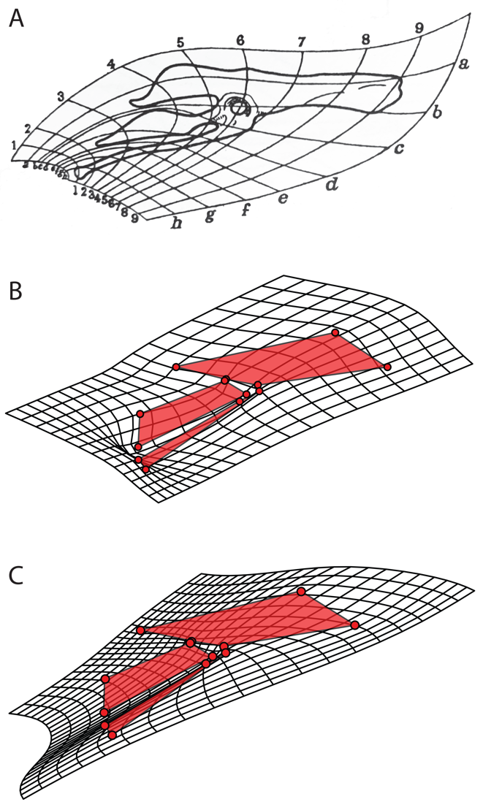
Figure S2. Pelvic deformation meshes from A. Thompson’s (1917: Fig. 162) comparison between Archaeopteryx and the extinct crown bird Apatornis, Illustration is in the public domain. B. our two-dimensional geometric morphometric analysis comparing Archaeopteryx and Coturnix and, C. our two-dimensional geometric morphometric analysis comparing an early-stage (HH28) Cortunix embryo and the mature Coturnix.

Supplementary Text S2. Supplementary Methods
a. CLARITY protocol. The CLARITY protocol (Chung et al. 2013) permits biological tissues to be made almost completely transparent while retaining both fine-scale anatomical structure and proteins, making it perfect for visualizing protein expression in the tissues of early embryos. Our embryos were fixed with paraformaldehyde (PFA)/phosphate-buffered saline (PBS) and stored in 100% methanol in plastic test tubes. We first bleached the embryos by replacing the 100% methanol with an 80% methanol, 10% hydrogen peroxide, 10% dimethylsulfoxide (DMSO) (8:1:1 ratio) solution and placing them under lamp light under motion for 24 hours, after which the embryos were bleached and whitened. Following this, we replaced the bleaching solution with 100% methanol and placed the embryos under motion for 15 minutes, until they sank back to the bottom of the tube. We prepared 75%, 50%, and 25% methanol solutions with 100% PBS as a solvent (we created PBS 1X by mixing 100 mL of a stock solution of PBS 10X with 900 mL of deionized [DI] water). Lower concentrations of methanol were progressively replaced in the test tube, and the embryo was placed under motion for 15 minutes to equilibrate with this new concentration. After the embryo equilibrated with the 25% methanol solution, we replaced the solution with 100% PBS and let sit under motion for 15 more minutes.
We prepared the CLARITY solution to create a hydrogel monomer: 160 mL of water, 20 mL of PBS 10X, 20 mL of acrylamide (40%) in an 8:1:1 ratio, with the addition of 0.5 g of VA-040 as an initiator, keeping the solution on ice at all times to prevent polymerization. We also added 250 μL of 0.05% bis-acrylamide to cross link samples for greater stability and tissue integrity for cutting later. We replaced the 100% PBS solution with ~35 mL of the CLARITY solution and set the embryos with the CLARITY solution under 4°C under motion for 24 hours.
We next prepared rubber stoppers for the test tubes that were punctured by two large syringe needles to allow gas to enter and escape the test tube while retaining a tight seal elsewhere. Each needle was connected to a valve that allowed for gas flow to be turned on and off and permitted the needles to be connected to nitrogen gas or vacuum. Together, this created a stopper that allows gases to be removed and pumped into the test tube without contamination from surrounding air—oxygen will prevent the reaction from proceeding properly. We placed these rubber stoppers on the test tubes firmly, keeping the stopper valves open while pressing the stopper into the test tube to ensure the stopper was far into the test tube. Each needle of a stopper was attached to a source of either nitrogen gas or vacuum, such that each stopper had one input for nitrogen gas and one input for vacuum. To completely replace the air inside the test tube with nitrogen gas, we alternated 5 minutes of vacuum, 5 minutes of nitrogen gas for 2-3 cycles—if the stoppers came off the tube, the process had to be restarted. Following this (and with both valves of the stopper closed, to ensure no air could enter the stopper) we placed the test tubes in a 37°C water bath under motion for 3 hours. Following this, we removed the CLARITY solution (which had a gel-like consistency at this point), keeping the embryos in the test tube, replaced it with PBS 1X, and let the tube sit under motion for 1 hour. We replaced the PBS with a new wash and set the test tube under motion for another hour.
To prepare the embryos for cutting, we replaced the PBS with HCL solution (1 M HCl diluted 5:2 with DI water) and placed the tube under motion in a 37°C heater for 30 minutes. Following this, we washed the embryos twice with PBS 1X. We cut embryos with fine scissors transversely across the torso to retain pelvic, hindlimb, and proximal tail anatomy. We then placed the embryos in 4% sodium dodecyl sulfate (SDS; in solution with DI water and 0.2% boric acid). We placed the embryonic pelves in the 37°C heater under motion for about 1 week, or until the embryonic hips were cleared and transparent. After clearing, we stored the embryos at room temperature: we washed 3 times with PBS detergent solution (PBSt; PBS 1X, 0.5% Triton X-100) (~1 hour each wash), and for extended shelf life we added a small amount of sodium azide (0.1% of the solution) to prevent contamination.

b. Immunostaining embryonic pelves. We used immunostaining to visualize tissue-specific proteins in the A. mississippiensis and C. c. japonica embryos, allowing embryonic morphology to be made clear and unambiguous. Before immunostaining, we conducted three 30-minute washes with PBSt. Each primary antibody solution (3,000 μL) was made with 89% PBSt (2,670 μL), 5% DMSO to help antibody penetration (150 μL), 1% sodium azide (30 μL), and the primary antibodies that were used. See Table S1 for concentrations of primary antibodies used in each primary antibody solution. Secondary antibody solutions were made in the same way except all secondary antibodies were added at a 1:500 concentration. Secondary antibodies were selected based on their reaction to primary antibodies and nonconflicting florescent wavelengths. For example, an embryo with primary antibodies for SOX-9, collagen 2, and collagen 9 would be stained with anti-rabbit, anti-mouse IgG2, and anti-mouse IgG1 secondary antibodies that all fluoresce at different wavelengths. Although we used a maximum of three primary antibody combinations in this study (Table S2), we have since successfully stained for up to six different target proteins in the same embryo. Supplier information can be found in Table S1.

Table S1. List of antibodies by their antigen (target protein), host type, the isotype (in the case of mouse antibodies), the concentration we used in the primary antibody solution, and the supplier (where we purchased the antibody, with catalog code in parentheses). CTS is Cell Signaling Technologies, DSHB is the Developmental Studies Hybridoma Bank.

Antigen | Host | Mouse Isotype | Concentration | Supplier
SOX-9 | Rabbit | NA | 1:1000 | CST (AB5535)
Collagen II | Mouse | IgG2a | 1:40 | DSHB (CIIC1)
Collagen IX | Mouse | IgG1 | 1:50 | DSHB (2C2-s)
MF-20 | Mouse | IgG2b | 1:40 | DSHB (MF 20-s)
NF-M | Mouse | IgG1 | 1:50 | DSHB (3A10)
Tenascin | Mouse | IgG1 | 1:40 | DSHB (M1-B4)
Collagen I | Mouse | IgG1 | 1:40 | DSHB (SP1.D8)

Taxon | Target Protein Combination | Embryonic stages stained
Alligator | SOX-9, Collagen II | F13–19
Alligator | MF-20, NF-M, Collagen I | F13–17, F20
Alligator | MF-20, Collagen II, Collagen I | F13–19
Coturnix | MF-20, Collagen I, Tenascin | HH24, 27, 29–32
Coturnix | SOX-9, MF-20, NF-M | HH24, 29, 30, 34
Coturnix | SOX-9, Collagen II, Collagen IX | HH28–31, 34
Gallus | XOX-9, Collagen I, MF-20 | HH29, 34
Melopsittacus | SOX-9, MF-20, NF-M | HH31, 35
Nothoprocta | SOX-9, MF-20, NF-M | HH30, 34
Table S2. Combinations of target protein combinations stained for by primary antibodies in embryonic series of Alligator mississippiensis, Coturnix coturnix japonica, Gallus gallus domesticus, Melopsittacus undulatus, and Nothoprocta perdicaria. Embryonic stages follow Ferguson (F stages; 1985) and Hamburger and Hamilton (HH stages; 1951) as also described by Ainsworth et al. (2010).

c. Creating refractive index matching solution (RIMS). Before confocal microscopy of cleared and stained embryos it was necessary to mount them in a solution with the same refractive index as air to prevent light distortion during image capture. We made refractive index matching solution (RIMS) by dissolving 40 g of HistoDenz nonionic density gradient medium (Sigma-Aldrich, catalog code D2158) in 30 mL of 0.2 M phosphate buffer, then adding 30 μL of 10% sodium azide. To make the phosphate buffer we combined 40 μL of 1 M dibasic sodium phosphate, 260 μL of 1 M monobasic sodium phosphate and 49 mL of DI water. We then placed this RIMS solution in 37°C heat, swirling gently once per hour until entirely dissolved. We stored the RIMS in a clean, sealed container and always used a fresh pipette when removing RIMS to ensure that no contamination of the solution would change the refractive index.
We made the 1% agarose RIMS by gently stirring 0.2 g of low-melting agarose into 20 mL of RIMS at 60°C, kept at this temperature using a water bath on a hot plate. We stored the 1% agarose RIMS at 45°C and re-melted it in a water bath before each use.

d. Computed Tomography (CT) scanning and construction of 3D meshes. The details of the CT scanning conducted at Yale University are described in the main text. In addition to these scans, one specimen of Coelophysis bauri was scanned at the UTCT (University of Texas at Austin High-Resolution X-Ray CT Facility) using a NorthStar Imaging scanner at 180 kV and 0.16 mA using an aluminum filter. We 3D surface scanned a high-quality research cast of Heterodontosaurus tucki at Virginia Tech (VT) using an Artec 3D Space Spider high-resolution 3D surface scanner (1 mm resolution) and processed these scans with Artec Studio 13 software to produce an *.stl file of the pelvis. The 3D surface scan of the Allosaurus pelvis was conducted at the Yale Peabody Museum with an Artec 3D Space Spider (0.3 mm resolution) and processed with Artec Studio 13 software. All specimens are provided in Table S3.

Table S3. Taxa and specimens used in geometric morphometric analyses along with the method the 3D meshes of these pelves were acquired.
Taxon | Specimen Number | Method
Sphenodon punctatis | YPM HERR 011419 | CT scan (Yale)
Euparkeria capensis | SAM-PK-6049 | CT scan (Yale)
Alligator mississippiensis | UF-Herp-21461 | Downloaded from MorphoSource (morphosource.org, M22299)
Melanosuchus niger | RVC-JRH-FBC1 | Downloaded from CrocBase (osf.io/6zamj)
Crocodylus niloticus | RVC-JRH-FNC0 | Downloaded from CrocBase (osf.io/6zamj)
Paleosuchus palpebrosus | RVC-JRH-PP1 | Downloaded from CrocBase (osf.io/6zamj)
Heterodontosaurus tucki | SAM-PK-K1332 | Surface scan of research cast (VT)
Coelophysis bauri | MCZ 4330 | CT scan (UTCT)
Allosaurus fragilis | YPM 4944 | Surface scan (Yale)
Tyrannosaurus rex | USNM PAL 555000 | Smithsonian 3D model (3d.si.edu)
Ornitholestes hermanni | AMNH 619 | CT scan (Yale)
Shuvuuia deserti | IGM N 100/99 | Chiappe et al. 2002, Fig. 4.21A (2D only)
Citipati osmolskae | IGM 100/978 | CT scan (Yale)
Rahonavis ostromi | UA 8656 | CT scan (Yale)
Velociraptor mongoliensis | IGM 100/985 | CT scan (Yale)
Archaeopteryx lithographica | WDC-CSG-100 and MB.Av.101 | Laminography and macrophotogrammetry (see below; provided by RMC)
Balaur bondoc | EME PV.313 | Brusatte et al. 2013, Fig. 27A (2D only)
Ichthyornis dispar | KUVP 119673 | CT scan (Yale)
Crypturellus noctivagus | YPM ORN 102518 | CT scan (Yale)
Coturnix coturnix | YPM ORN 103764 | CT scan (Yale)

e. Pelvic reconstruction of Archaeopteryx lithographica
The Archaeopteryx lithographica pelvis used in our analyses was a composite reconstruction modeled using macrophotogrammetric reconstructions of the Thermopolis (WDC-CSG-100; right ischium, pubis) and Berlin (MB.Av.101; right ilium) specimens, as well as radiographic reconstructions of the right ischium and pubis from the Thermopolis specimen. The following radiography description has been adapted from Carney (2016, pp. 61–67).
Digital X-ray imaging of the Thermopolis specimen was conducted periodically over 15 months, using systems developed and built at the Lawrence Livermore National Laboratory (LLNL) in Livermore, California, USA. We irradiated the specimen using rotational computed laminography, and the resulting projections were reconstructed using multiplanar tomosynthesis (Gondrom & Schröpfer 1999; note that laminography and tomosynthesis are often used synonymously, Bossi et al. 2002). Laminography differs from CT by virtue of its irradiation geometry, in which the rotation axis provides an acute angle between the incident X-ray beam and sample surface. Laminography is therefore more optimal for 3D scanning flat samples like the Archaeopteryx specimen (Gondrom and Schröpfer 1999, Bossi et al. 2002, Xu et al. 2012). The imaging system consisted of a microfocus X-ray source (Kevex PXS10; Thermo Electron Corporation) and a 16-inch, 200 μm pixel amorphous silicon flat panel detector (XRD 1620 AN14 CS; PerkinElmer Inc.) with a gadolinium oxysulfide scintillator screen (DRZ Standard; Mitsubishi Chemical Holdings Corporation). We positioned the fossil horizontally on a Plexiglas tube mounted to a motorized rotation stage (Newport RV160PP), with the source and detector at 45° with respect to the plane of the fossil. Data was acquired as 16-bit datasets using LLNL software, and scanned at 130 kV and 0.27mA, in 720 projections over 360°. The datasets comprised a total of 26 scans acquired on four occasions over six months, including 19 scans acquired at 40.0 μm voxel resolution (5X), six scans at 70.5μm (2.8X), and one scan at 46.5μm (4.1X; imaged using the Thales panel described above). The actual magnification changes with the slice depth, so each slice was normalized by resampling. We calculated the voxel dimensions used for this resampling by imaging a calibration phantom, a customized piece of plastic with holes of a known size drilled into it to serve as fiducial markers.
We processed these radiographic datasets using a sequence of proprietary algorithms developed at LLNL. Prior to segmentation, we imported each image stack into ImageJ (Schneider et al. 2012) using custom LLNL plugins, then resampled by more closely bracketing the histogram range, then downsampling to 16-bit, downsampling to 8-bit, and rotating as necessary. These resampling steps were necessary for optimizing the range of grayscale values for segmentation, which was conducted using Avizo software (Avizo Fire 8, Avizo 9; FEI). We used the 3D modeling software, Geomagic Studio 12 (3D Systems) to conduct post-processing operations such as smoothing, hole filling, mirroring, and merging.
Given certain data loss artifacts inherent to the laminographic scanning (Carney 2016), coupled with the relatively poor preservation of the ilium, we also conducted macrophotogrammetry to complement the X-ray datasets. Light photographs of the Thermopolis and Berlin (MB.Av.101) specimens were taken using a Canon EOS 7D 18.0MP DSLR camera, primarily using a 100mm f/2.8 Canon macro lens. This yielded a total of 16,780 and 6,218 JPEG images, respectively, from which regional subsets were manually selected. We used RealityCapture CLI photogrammetry software (Capturing Reality) to generate 3D polygonal meshes (*.obj), and ZBrush 4R8 digital sculpting software was used to UV unwrap each bone for retexturing in RealityCapture to yield 4096x4096 texture maps (*.tif) (Kirk et al., in prep). We used Geomagic Wrap 2017 software for post-processing the 3D meshes, such as noise reduction, cleaning (Mesh Doctor), and trimming; models were exported in *.obj format.
Reconstruction (compositing and modeling) was conducted using the 3D modeling and animation software Maya 2017 (Autodesk, Inc., Mill Valley, CA USA). Bone models of the Berlin specimen (Fig. S3) were scaled to those of the Thermopolis specimen based on pubis length. Pelvic width and mediolateral orientation of the ischium were based on the reconstruction of Wellnhofer (2009: Fig. 6.12b). The rostral end of the ilium (which is damaged in the Berlin specimen) was reconstructed based on that of the London specimen (NHMUK PV OR 37001) and Wellnhofer reconstruction (Wellnhofer 2009: Fig. 6.12a). The orientation (pitch) of the proximal pubis was reconstructed based on that of the Munich specimen (main slab, BSP 1999 I 50; Wellnhofer 2009: Fig. 5.110), given that “[t]he [Munich specimen's] ischium shows the same morphology as in the Eichstätt and Thermopolis specimens. Proximally, the pubis has its natural orientation preserved undisturbed, indicating a relatively steep ventro-caudal orientation as was shown already for the other specimens that have the pubis preserved” (Wellnhofer 2009: p.111).
We deemed retrodeformation unnecessary given the lack of observable taphonomic distortion. Using the radiographic (X-ray) and photogrammetric models as references, a low poly composite pelvis was manually modeled using the Modeling Toolkit operations and box modeling technique (Fig. S4, scaffolding). The Transfer Maps operations were used to transfer the photogrammetry textures onto the composite pelvis model (Fig. S5) and generate a composite 4096x4096 texture map (*.png). Finally, the composite model was exported in *.stl format (which triangulates the quads), as original and smoothed (Smooth > Division levels: 1) versions (Fig. S4).

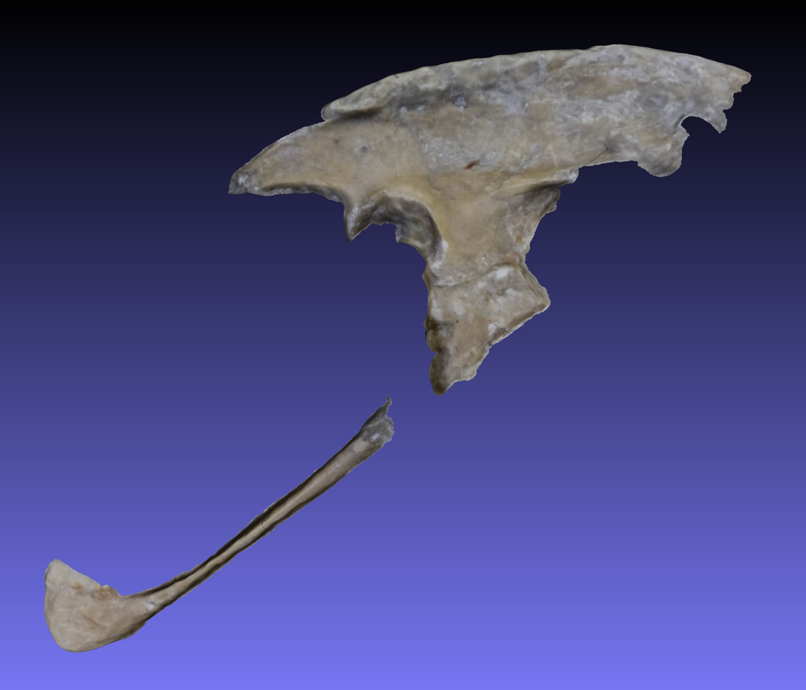
Figure S3. 3D polygonal mesh of the in situ right ilium and pubis of the Berlin specimen (MB.Av.101), reconstructed via macrophotogrammetry. Screenshot from MeshLab v2016.12.

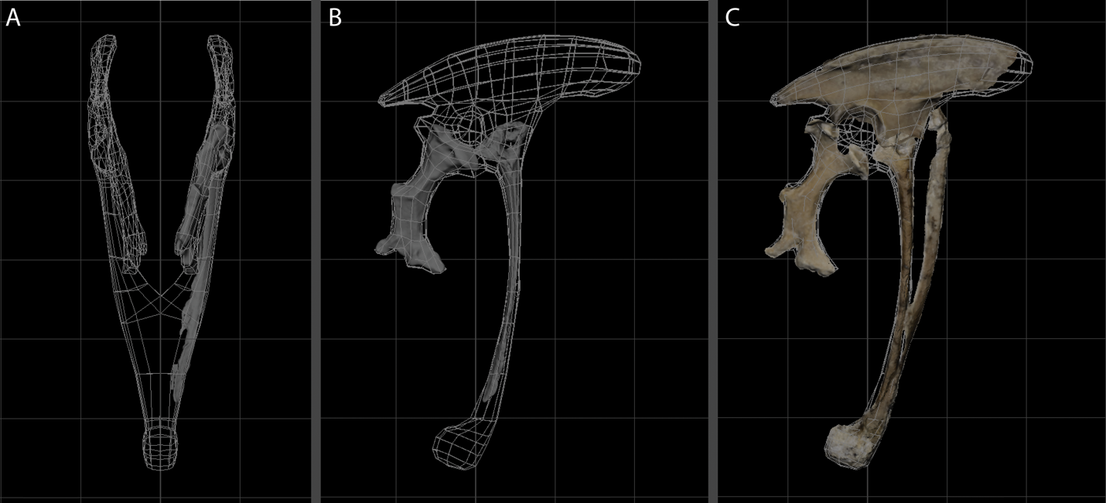
Figure S4. Orthogonal views of the composite 3D pelvis model (quad scaffolding), based on X-ray (gray) and macrophotogrammetric (photographic) models of the right ischium and pubis of the Thermopolis specimen (WDC-CSG-100), and the right ilium of the Berlin specimen (MB.Av.101). A. Caudal view, X-ray. B. Right lateral view, X-ray. C. Right lateral view, macrophotogrammetry—the left in situ pubis is also shown for the Thermopolis specimen. Screenshots from Maya 2017.

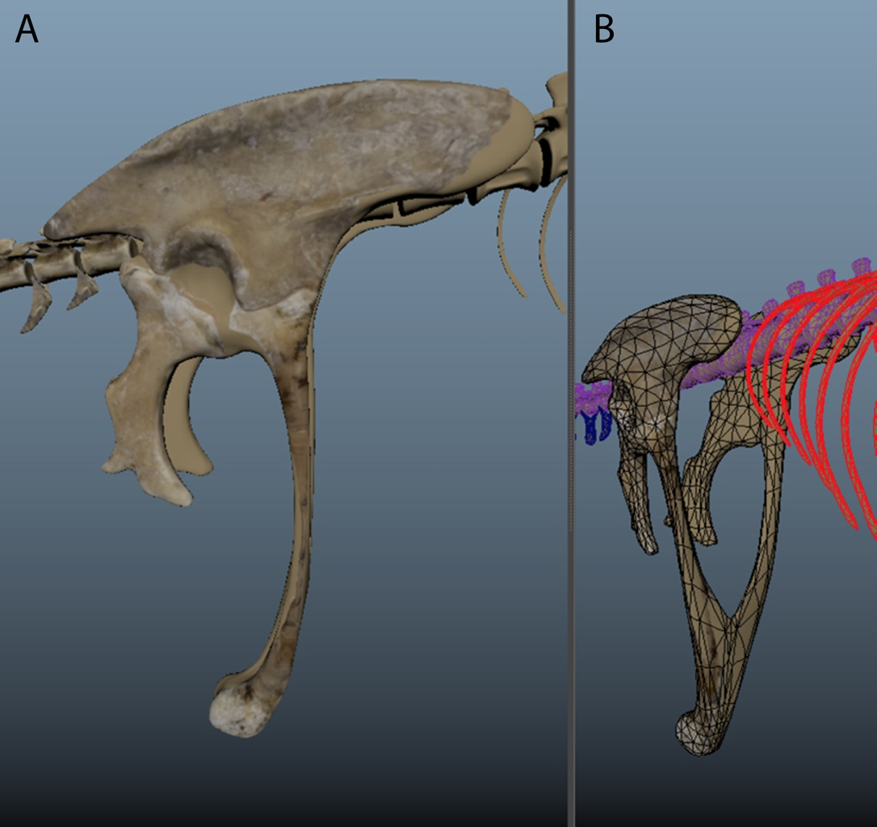
Figure S5. A. Right lateral and B. anterior oblique views of the composite 3D pelvis model with photogrammetric textures applied. Solid tan color represents modeled surfaces (i.e., no photogrammetry data). Screenshot from Maya 2017, shown triangulated and in Smooth Mesh Preview mode.

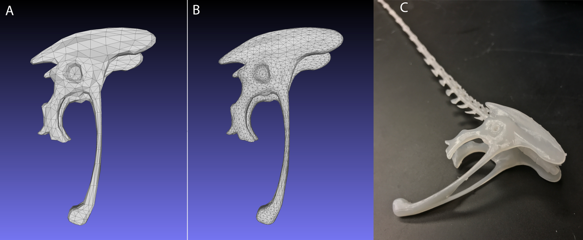

Figure S6. Screenshot of the A. original and B. smoothed *.stl low poly models, from MeshLab v2016.12. C. Light photograph of a test resin 3D print.
f. Geometric morphometrics landmarks. For clarity and consistency, we have included both verbal descriptions of the 13 geometric morphometric landmarks used in our analyses and illustrated these landmarks in Figure S7.
Landmark 1. Anteriormost point of iliac blade
Landmark 2. Dorsalmost point of iliac blade
Landmark 3. Posteriormost point of iliac blade
Landmark 4. Posteriormost point on ilium of the articular surface of the acetabulum
Landmark 5. Anterodistalmost point on ilium of the articular surface of the acetabulum
Landmark 6. Anteriormost point on pubis of the proximal articular surface
Landmark 7. Anteriormost[plesiomorphic]/ventralmost[derived] point on the distal end of the pubis
Landmark 8. Posteriormost[plesiomorphic]/dorsalmost[derived] point on the distal end of the pubis
Landmark 9. Ventralmost point of the pubis-ischium articulation surface of the pubis
Landmark 10. Anteriormost point of the proximal end of the ischium
Landmark 11. Anteriormost[plesiomorphic]/ventralmost[derived] point of the distal end of the ischium
Landmark 12. Posteriormost[plesiomorphic]/dorsalmost[derived] point of the distal end of the ischium
Landmark 13. Posteriormost point of the proximal end of the ischium

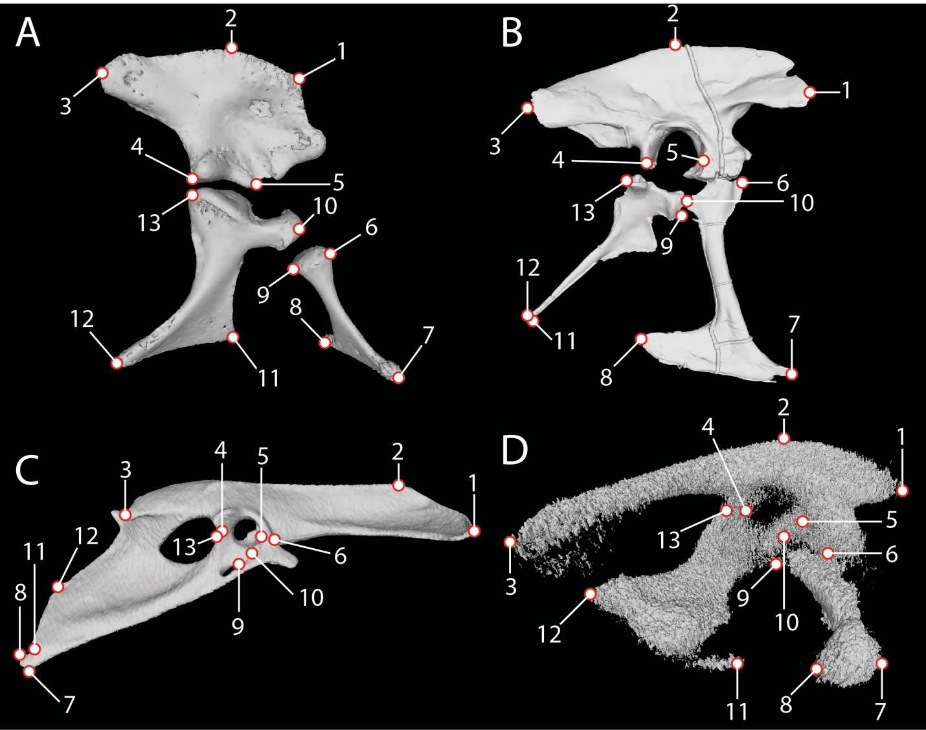
Figure S7. The 13 geometric morphometric landmarks illustrated on hemipelves of A. Alligator mississippiensis, B. Tyrannosaurus rex, C. Coturnix cortunix, and D. embryonic Coturnix coturnix japonica in right lateral view.

g. Institutional Abbreviations. AMNH, American Museum of Natural History, New York, New York, USA; EME PV, Vertebrate Paleontology Collection, Transylvanian Museum Society, Cluj-Napoca, Romania; IGM, Mongolian Institute of Geology, Ulaanbaatar, Mongolia; KUVP, University of Kansas, Museum of Natural History, Vertebrate Paleontology Collection, Lawrence, Kansas, USA; MB, Museum für Naturkunde, Berlin, Germany; MCZ, Harvard Museum of Comparative Zoology, Cambridge, Massachusetts, USA; RVC, Royal Veterinary College, London, England; SAM, South African Museum, Cape Town, South Africa; UA, University of Antananarivo, Antananarivo, Madagascar; UF, University of Florida, Florida Museum of Natural History, Gainsville, Florida, USA; USNM, National Museum of Natural History, Smithsonian Institution, Washington, D.C., USA; WDC, Wyoming Dinosaur Center, Thermopolis, Wyoming, USA; YPM, Yale Peabody Museum, New Haven, Connecticut, USA

Supplementary Text S3. Description of Alligator pelvic development
To provide an extant comparative sample we also performed the same CLARITY protocol on an ontogenetic series of Alligator mississippiensis embryonic pelves. Although the pelvis of A. mississippiensis is different from the archosaurian common ancestor in several ways (most notably, a mobile pubis, Claessens 2004), it retains many plesiomorphic pelvic morphologies for archosaurs and more broadly, reptiles (e.g., forward-facing pubis, shortened ilium, elongated muscular tail, closed pubic symphysis). The pelvis of A. mississippiensis shows little variation through embryonic development, retaining the same character states in both cartilaginous and ‘soft’ tissues. The tail remains proportionately large throughout, the ilium remains anteroposteriorly short, and the pubis retains roughly the same angle of deflection throughout ontogeny, although it is generally slightly more ventrally projecting (Fig. 2). Notably, throughout A. mississippiensis development the pubis and ischium retain the unique crocodyliform configuration of a mobile pubis that articulates solely with the ischium (Fig. 2). The distal ends of the pubis remain unfused (i.e., open pubic symphysis) in all sampled developmental stages, but the distal ends of the ischia fuse relatively early (around stage F14; Extended Data Fig. 5). The embryonic A. mississippiensis musculature appears similar to both the mature A. mississippiensis and early-stage Coturnix embryos, with a proportionately large CFL of the tail and comparatively reduced hip musculature (IF; Fig. 2). The tail musculature especially is similar in proportion to that of Coturnix embryos, and the pubic musculature (PIFE1+2) of embryonic A. mississippiensis differentiates earlier relative to the musculature of Coturnix, which is delayed until after pubic retroversion begins. The lumbosacral plexus retains the typical crocodylian morphology throughout ontogeny (Fig. 2C).

Supplementary Text S4. Pelvic covariances among the Ornithischia
Ornithischia is lineage of dinosaurs that independently evolved birdlike pelves with retroverted pubes and lengthened ilia. To preliminarily investigate if the same covariance relationships hold between ornithischians as in other archosaurs, we collected proportional data from taxa across Ornithischia using Fiji (Schindelin et al. 2012) for ImageJ (v. 2.0.0; Schneider et al. 2012) as described in the main text: Heterodontosaurus tucki (SAM-PK-K1332), Hypsilophodon foxii (Galton 1969), Homalocephale calathocercos (Maryańska and Osmolska 1974), Uteodon aphanoecetes (Carpenter and Wilson 2008), Gasparinisaura cincosaltensis (Coria and Salgado 1996), Kentrosaurus aethiopicus (Mallison 2009), Lesothosaurus diagnosticus (Sereno 1991), Maisasaura peeblesorum (Dilkes 1999), Montanoceratops cerorhynchos (Brown and Schlaikjer 1942), Psittacosaurus mongoliensis (Osborn 1924), Stegosaurus stenops (Gilmore 1914), and Thescelosaurus sp. (Galton 1969).
The ornithischian pelvis possesses different covariances than other archosaurs (Extended Data Fig. 10). For example, in ornithischians the pubic length decreases with a decreasing pubic angle, the length of the pubis increases with decreasing pubic angle in both paravians and archosaurs without retroverted pubes. This suggests that the ornithischian pelvis, although superficially avialan-like, evolved to have different pelvic covariation than the ancestral condition, whereas the pelvis of avialans resides on a continuum with the ancestral pelvic condition. We hypothesize that this is because the muscular configurations have been reconstructed as very different for ornithischians than other dinosaurs: the pubis is reduced in shaft thickness and length in these taxa, such that it was not the origin for most of the pelvic muscles (e.g., Mm. puboischiofemoralis 1 et 2) that originate from the pubis in other taxa (Galton 1969; 1970; Maidment and Barrett 2011; 2012). Determining whether functional differences and the release of functional constraints have created different pelvic modules in ornithischians will require further work, but recent work suggests a shift in the respiratory function of the pelvis (and particularly the pubis) occurred early in ornithischian evolution (Radermacher et al. 2021), which is consistent with this our hypothesis.

Supplementary Text S5. Supplementary References
Ainsworth, S. J., R. L. Stanley, and D. J. R. Evans. 2010. Developmental stages of the Japanese quail. Journal of Anatomy 216:3-15.
Bossi, R. H., F. A. Iddings, G. C. Wheeler, and P. O. Moore. 2002. Nondestructive Testing Handbook: Radiographic Testing (Vol. 4). American Society for Nondestructive Testing, Columbus.
Broom, R. 1905. On the early development of the appendicular skeleton of the ostrich, with remarks on the origin of birds. Transactions of the South African Philosophical Society 16:355–368.
Brown, B., and E. M. Schlaikjer. 1942. The skeleton of Leptoceratops with the description of a new species. American Museum Novitates 1169:1–15.
Brusatte, S. L., M. Vremir, Z. Csiki-Sava, A. H. Turner, A. Watanabe, G. M. Erickson, and M. A. Norell. 2013. The osteology of Balaur bondoc, an island-dwelling dromaeosaurid (Dinosauria: Theropoda) from the Late Cretaceous of Romania. Bulletin of the American Museum of Natural History 2013:1-100.
Bunge, A. 1880. Untersuchungen zur entwickelungsgeschichte des beckengürtels der amphibien, reptilien, und vögel. Universität Dorpat, 54 pp.
Carney, R. M. 2016. Evolution of the archosaurian shoulder joint and the flight stroke of Archaeopteryx. PhD dissertation, Brown University.
Carpenter, K., and Y. Wilson. 2008. A new species of Camptosaurus (Ornithopoda: Dinosauria) from the Morrison Formation (Upper Jurassic) of Dinosaur National Monument, Utah, and a biomechanical analysis of Its forelimb. Annals of Carnegie Museum 76:227-263.
Chiappe, L. M., M. A. Norell, and J. M. Clark. 2002. The Cretaceous, short-armed Alvarezsauridae: Mononykus and its kin; pp. 87–120 in L. M. Chiappe and L. M. Witmer (eds.), Mesozoic Birds: Above the Heads of Dinosaurs. University of California Press, Berkeley.
Chung, K., J. Wallace, S.-Y. Kim, S. Kalyanasundaram, A. S. Andalman, T. J. Davidson, J. J. Mirzabekov, K. A. Zalocusky, J. Mattis, A. K. Denisin, S. Pak, H. Bernstein, C. Ramakrishnan, L. Grosenick, V. Gradinaru, and K. Deisseroth. 2013. Structural and molecular interrogation of intact biological systems. Nature 497:332–337.
Claessens, L. P. A. M. 2004. Archosaurian respiration and the pelvic girdle aspiration breathing of crocodyliforms. Proceedings of the Royal Society B 271:1461–1465.
Claessens, L. P. A. M., and M. K. Vickaryous. 2012. The evolution, development and skeletal identity of the crocodylian pelvis: Revisiting a forgotten scientific debate. Journal of Morphology 273:1185-1198.
Cope, E. D. 1866. On the Cyprinidae of Pennsylvania. Transactions of the American Philosophical Society 13:351–399.
Cope, E. D. 1870b. On the hypothesis of evolution: physical and metaphysical, reprinted from Lippincott’s Magazine in Cope 1887, pp. 128–214.
Cope, E. D. 1887. The Origin of the Fittest. MacMillan, New York, 467 pp.
Coria, R. A., and L. Salgado. 1996. A basal iguanodontian (Ornithischia: Ornithopoda) from the Late Cretaceous of South America. Journal of Vertebrate Paleontology 16:445-457.
Creese, M. R. S. 2000. Ladies in the Laboratory? American and British Women in Science, 1800-1900. Scarecrow Press, London.
Dilkes, D. W. 1999. Appendicular myology of the hadrosaurian dinosaur Maiasaura peeblesorum from the Late Cretaceous (Campanian) of Montana. Transactions of the Royal Society of Edinburgh: Earth Sciences 90:87-125.
Ferguson, M. W. J. 1985. Reproductive biology and embryology of the crocodilians; pp. in C. Gans, F. Billett, and P. Maderson (eds.), Biology of the Reptilia. John Wiley and Sons, New York.
Galton, P. M. 1969. The pelvic musculature of the dinosaur Hypsilophodon (Reptilia: Ornithischia). Postilla 131:1–64.
Galton, P. M. 1970. Ornithischian dinosaurs and the origin of birds. Evolution 24:448-462.
Gauthier, J. A. 1984. A cladistics analysis of the higher systematic categories of the Diapsida. Ph.D. dissertation thesis/dissertation, University of California, Berkeley, Berkeley, CA, 564 pp.
Gauthier, J. A. 1986. Saurischian monophyly and the origin of birds; pp. 1–55 in K. Padian (ed.), Memoirs of the California Academy of Sciences 8, San Francisco, CA.
Gilmore, C. W. 1914. Osteology of the armoured Dinosauria in the United States National Museum, with special reference to the genus Stegosaurus. United States National Museum Bulletin 89:1–143.
Gondrom, S., and S. Schröpfer. 1999. Digital computed laminography and tomosynthesis—functional principles and industrial applications. Journal of Nondestructive Testing & Ultrasonics 7.
Goodrich, E. S. 1930. Studies on the Structure and Development of Vertebrates. MacMillan, Toronto, 837 pp.
Gould, S. J. 1977. Ontogeny and Phylogeny. Harvard University Press, Cambridge.
Haeckel, E. 1866. Generelle Morphologie der Organismen. Allgemeine Grundzüge der organischen Formen-Wissenschaft, mechanisch begründet durch die von Charles Darwin reformirte Descendenz- Theorie. Georg Reimer, Berlin.
Haeckel, E. 1874. Anthropologenie: Keimes- und Stammes-Geschichte des Menschen. W. Engelmann, Leipzig, 732 pp.
Hamburger, V., and H. L. Hamilton. 1951. A series of normal stages in the development of the chick embryo. Journal of Morphology 88:49–92.
Hamilton, H. L. 1952. Lillie’s development of the chick. An introduction to embryology. Henry Holt and Company, New York.
Heilmann, G. 1926. The Origin of Birds. D. Appelton, New York.
Hoffman, C. K. 1876. Beitrage zur Kenntniss des Beckens der Amphibien und Reptilien. Niederländisches Archiv fü r Zoologie 3:143–194.
Hutchinson, J. R. 2001. The evolution of pelvic osteology and soft tissues on the line to extant birds (Neornithes). Zoological Journal of the Linnean Society 131:123-168.
Huxley, T. H. 1870a. Further evidence of the affinity between the dinosaurian reptiles and birds. Quarterly Journal of the Geological Society of London 26:12–31.
Huxley, T. H. 1870b. On the classification of the Dinosauria, with observations on the Dinosauria of the Trias. Quarterly Journal of the Geological Society of London 26:32–51.
Huxley, T. H. 1870c. On Hypsilophodon foxii, a new dinosaurian from the Wealden of the Isle of Wight. Quarterly Journal of the Geological Society of London 26:3–12.
Huxley, T. H. 1879. On the characters of the pelvis in the Mammalia, and the conclusions respecting the origin of mammals which may be based on them. Proceedings of the Royal Society of London 28:190–195.
Hyatt, A. 1866. On the parallelism between the different stages of life in the individual and those in the entire group of the molluscous order Tetrabranchiata. Memoirs read before the Boston Society of Natural History 1:193–209.
Johnson, A. 1883. On the development of the pelvic girdle and skeleton of the hind limb of the chick. The Quarterly Journal of Microscopical Science 23:399–411.
Johnson, A. 1884. On the changes and ultimate fate f the blastopore in the newt. Proceedings of the Royal Society of London 37:65–66.
Kirk, A. M., A. Baines, H. Kaplan, and R. M. Carney. In prep. Creating 3D models using macrophotogrammetry and multimodal compositing.
Lebedinsky, N. G. 1913. Beiträge zur morphologie und entwicklungsgeschichte des vogelceckens. Jenaische Zeitschrift für Naturwissenschaften 50:647–774.
Maidment, S. C. R., and P. M. Barrett. 2011. The locomotor musculature of basal ornithischian dinosaurs. Journal of Vertebrate Paleontology 31:1265-1291.
Maidment, S. C. R., and P. M. Barrett. 2012. Does morphological convergence imply functional similarity? A test using the evolution of quadrupedalism in ornithischian dinosaurs. Proceedings of the Royal Society B 279:3765–3771.
Malashichev, Y., V. Borkhvardt, B. Christ, and M. Scaal. 2005. Differential regulation of avian pelvic girdle development by the limb field ectoderm. Anatomy and Embryology 210:187-197.
Mallison, H. 2010. CAD assessment of the posture and range of motion of Kentrosaurus aethiopicus Hennig 1915. Swiss Journal of Geosciences 103:211-233.
Maryańska, T., and H. Osmolska. 1974. Pachycephalosauria, a new suborder of ornithischian dinosaurs. Palaeontologia Polonica 30:45–102.
Maxwell, E. E., and H. C. E. Larsson. 2009. Comparative ossification sequence and skeletal development of the postcranium of palaeognathous birds (Aves: Palaeognathae). Zoological Journal of the Linnean Society 157:169-196.
Mehnert, E. 1887. Untersuchungen über die entwisklung des os pelvis der vögel. Morphologisches Jahrbuch 13:259–295.
Mehnert, E. 1891. Gastrulation und keimblätterbildung der Emys lutaria taurica. Morphologische Arbeiten 1:365–495.
Mehnert, E. 1895. Die individuelle variation des wirbelthierembryo. Morphologische Arbeiten 5:386–444.
Mehnert, E. 1897. Kainogenese. Morphologische Arbeiten 7:1–156.
Nowlan, N. C., and J. Sharpe. 2014. Joint shape morphogenesis precedes cavitation of the developing hip joint. Journal of Anatomy 224:482-489.
Osborn, H. F. 1900. Reconsideration of the evidence for a common dinosaur-avian stem in the Permian. Dinosaur Contributions, No. 4 The American Naturalist 34:777–799.
Osborn, H. F. 1924. Psittacosaurus and Protiguanodon: two Lower Cretaceous iguanodonts from Mongolia. American Museum Novitates 127:1–16.
Ostrom, J. H. 1969. Osteology of Deinonychus antirrhopus, an unusual theropod from the Lower Cretaceous of Montana. Bulletin of the Peabody Museum of Natural History 30:1–165.
Ostrom, J. H. 1973. The ancestry of birds. Nature 242:136.
Ostrom, J. H. 1975. The origin of birds. Annual Review of Earth and Planetary Sciences 3:55–77.
Ostrom, J. H. 1976. On a new specimen of the Lower Cretaceous theropod dinosaur Deinonychus antirrhopus. Breviora 439:1–21.
Ostrom, J. H. 1976. Archaeopteryx and the origin of birds. Biological Journal of the Linnean Society 8:91–182.
Owen, R. 1863a. On the fossil remains of a long-tailed bird (Archeopteryx macrurus, Ow.) from the lithographic slate of Solenhofen. Proceedings of the Royal Society of London 12:271–273.
Owen, R. 1863b. On the Archeopteryx of von Meyer, with a description of the fossil remains of a long-tailed species, from the lithographic stone of Solenhofen. Philosophical Transactions of the Royal Society of London 153:33–47.
Parker, J. T. 1891. Observations on the anatomy and development of Apteryx. Philosophical Transactions of the Royal Society of London 182:25–134.
Radermacher, V. J., V. Fernandez, E. R. Schachner, R. J. Butler, E. M. Bordy, M. Naylor Hudgins, W. J. de Klerk, K. E. J. Chapelle, and J. N. Choiniere. 2021. A new Heterodontosaurus specimen elucidates the unique ventilatory macroevolution of ornithischian dinosaurs. eLife 10:e66036.
Rasskin-Gutman, D., and A. D. Buscalioni. 2001. Theoretical morphology of the Archosaur (Reptilia: Diapsida) pelvic girdle. Paleobiology 27:59-78.
Rieppel, O. 2016. Phylogenetic systematics: Haeckel to Hennig. Taylor and Francis, Boca Raton, 381 pp.
Romanoff, A. L. 1960. The avian embryo. MacMillan, New York.
Romer, A. S. 1927a. The pelvic musculature of ornithischian dinosaurs. Acta Zoologica 8:225-275.
Romer, A. S. 1927b. The development of the thigh musculature of the chick. Journal of Morphology and Physiology 43:347–385.
Schindelin, J., I. Arganda-Carreras, E. Frise, V. Kaynig, M. Longair, T. Pietzsch, S. Preibisch, C. Rueden, S. Saalfeld, B. Schmid, J.-Y. Tinevez, D. J. White, V. Hartenstein, K. Eliceiri, P. Tomancak, and A. Cardona. 2012. Fiji: an open-source platform for biological-image analysis. Nature Methods 9:676-682.
Schmidt, H. 1909. Das biogenetische Grundgesetz Ernst Haeckel und seine Gegner Neuer Frankfurter Verlag, Frankfurt, 159 pp.
Schneider, C. A., W. S. Rasband, and K. W. Eliceiri. 2012. NIH Image to ImageJ: 25 years of image analysis. Nature Methods 9:671-675.
Sereno, P. C. 1991. Lesothosaurus, “Fabrosaurids,” and the early evolution of Ornithischia. Journal of Vertebrate Paleontology 11:168-197.
Smith, A. D., L. M. Chiappe, J. A. Clarke, S. V. Edwards, S. J. Nesbitt, M. A. Norell, T. A. Stidham, A. H. Turner, M. v. Tuinen, J. Vinther, and X. Xu. 2015. Rhetoric vs. reality A commentary on “Bird Origins Anew” by A. Feduccia. The Auk 132:467–480.
Starck, J. M. 1993. Evolution of Avian Ontogenies; pp. 275-366 in D. M. Power (ed.), Current Ornithology: Volume 10. Springer US, Boston, MA.
Switek, B. 2010. Thomas Henry Huxley and the reptile to bird transition; pp. 251–263 in R. T. J. Buffetaut, D. Naish, and D. M. Martill (eds.), Dinosaurs and Other Extinct Saurians: A Historical Perspective. Geological Society, London, Special Publications.
Thompson, D. 1961. On Growth and Form; J. T. Bonner (ed.). Cambridge University Press, Cambridge, 346 pp.
Wellnhofer, P. 2009. Archaeopteryx—The Icon of Evolution. Verlag Dr. Friedrich Pfeil, München.
Weismann, A. 1875. Ueber die Umwandlung des mexicanischen Axolotl in ein Amblystoma Zeitschrift für wissenschaftliche Zoologie (suppl.):297–334.
Weismann, A. 1881. Studies in the Theory of Descent. Translated and edited by R. Mendola. Sampson, London.
Weismann, A. 1904. The Evolution Theory. Edward Arnold, London.
Xu, F., L. Helfen, T. Baumbach, and H. Suhonen. 2012. Comparison of image quality in computed laminography and tomography. Optics Express 2-:794–806.

